**Excel**

**For Data Science**

**Auto fill: -**

It is basically filling the next values till selected cell, by Understanding the pattern of the values in between. But here you must give more than one value to get desired result.

EX: - Here it Understand the patten between the values we given and give the next coming values in the cells.

It Includes date, months, day, time, numbers, fractions, and names to repeat …

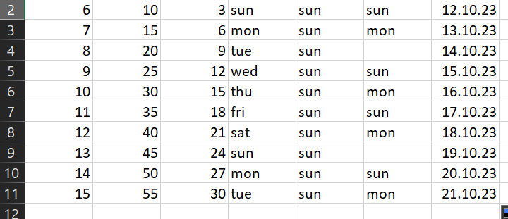

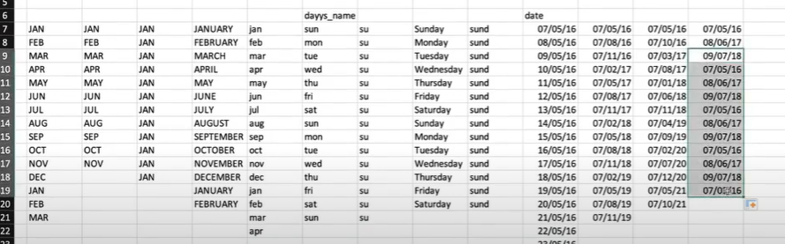

When you try date

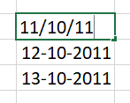

You can auto fill the Result also.

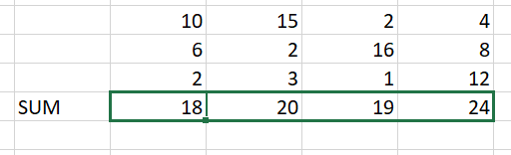

**SUM: -**

Used to add the all values we selected

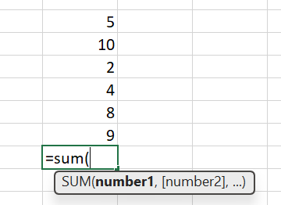

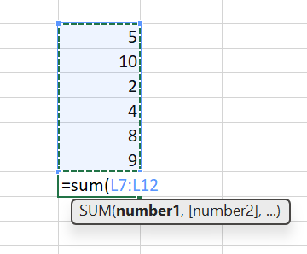

Here you can also select the cells to add the values in the syntax to do SUM Function and press Enter.

Once the cells are selected and added into any formula then, if the values are changed in the selected cells the Result effect Accordingly. But the values should be numerical.

**Table: -**

It is used to represent the values in better way in table

1st select the values to make it in table,

Go to Insert > click table and check the (my table have heeders) to form columns

Cntr+T 🡪 short cut or

select the values

select the values or cells

you can select by using mouse

Shift+cntr+ 🡪 arrow to select to right side same way change the arrow key to select required way. But it will select till the end.

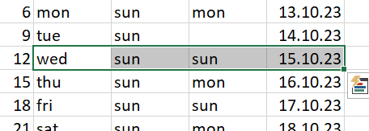

**FUNCTION: -**

Use = before using the Function or to use function start with = (Equals to)

SUM: - used to add values

AVG: - taking average (sum of values / No. of values)

Percentage: - marks obtained / total marks * 100

Round: - used to round the values which means removes the denominator of the value

If the vales above 5 in decimal, then it gives the next number else gives the same number without decimal values

Ex: - 2.345 🡪 2

3.6674 🡪 4

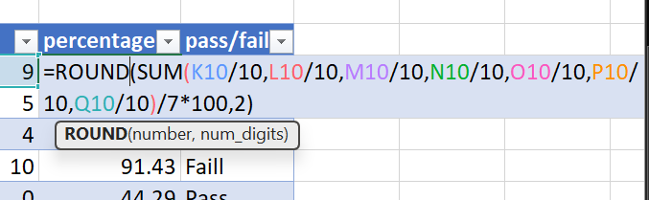

Count: - count the values or cells we selected

Min, max, floor, ceiling etc… and more

Filter Box: -

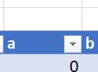

You can see the dropdown button beside the title of the column when we click on it

You can and You can do some changes

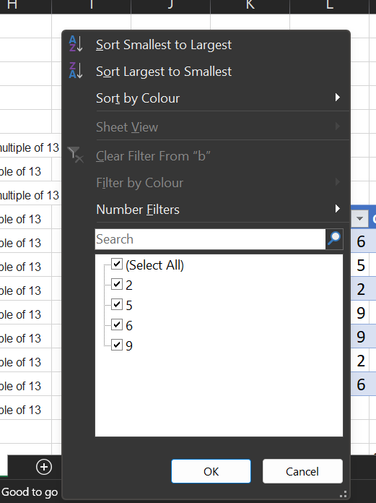

And: - both conditions should accept or True

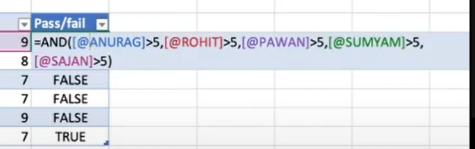

Or: - at least one condition should accept or True

**SUMIF: -** it is mostly used for sum up the values of repetitive values in another column.

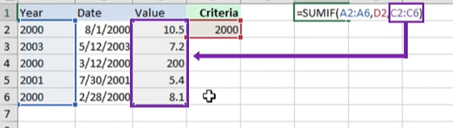

Criteria is 2000 here so it only sum up the values of year 2000.

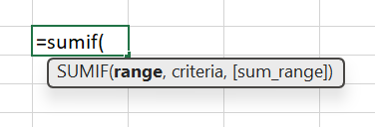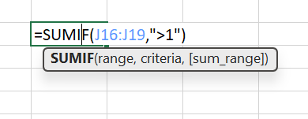

It is used sum the values if the criteria are accepted

Here if the total or sum value is grater then 1 (one) then it will show the sum value else it shows 0 (zero)

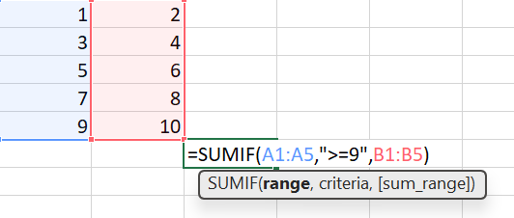

**=SUMIF: –** it’s a formula

**Range: -** it’s a range need to **select for criteria**, if the value in the criteria is accepted in the range, then only, we will get the desired result.

Obviously 9 is there in the range A1:A5 so it will accept the criteria else it gives result as 0,

If it accepts then it will ask sum range.

**Sum_range: –** it is used to get the result, it is the range where answer is present, like 9 is accepted by the range and criteria will check in the column range we select here we selected B1:B5 and according to criteria only value 10 is the greater than or equal to 9 so, answer is 10.

**Countif: -**

It is used to display the count of the values which selected cells accepted the criteria

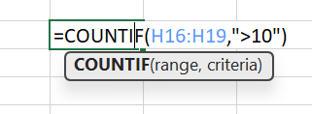

Here it gives the count of cells contains grater then the value 10

**Mod: -** gives the reminder not the duplicate values

Here number means select any cell or give any number

Divisor means give the number by which you want to divide the number

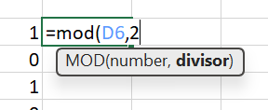

**Randbetween: -**

To get the random values from one number to another number

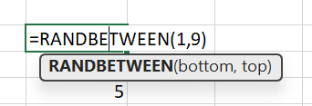Here we are getting random values from 1 to 9

But the values are changing randomly all the time,

So, to handle that 1st copy the values then go to past

Option on the top tap on drop down selects paste special

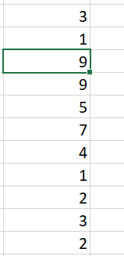Then select values then ok.

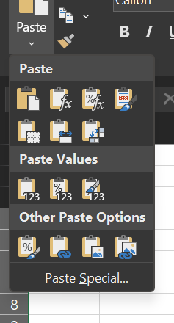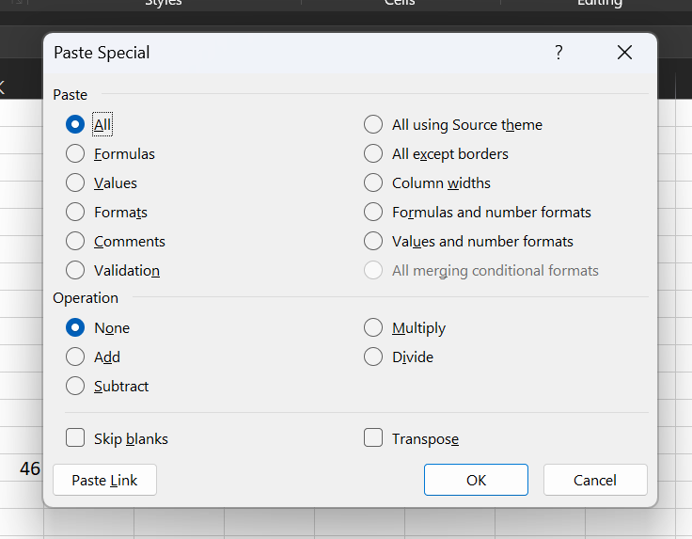

**If: -**

It is a conditional statement it works for getting if else conditions

The logical_test means we need to give the condition, then mention result for IF condition, 🡪 value_if_true, then for ELSE condition 🡪 value_if_false

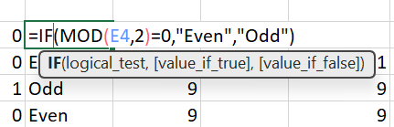

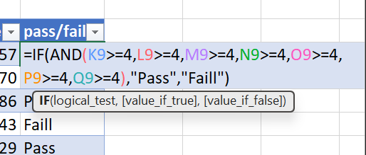

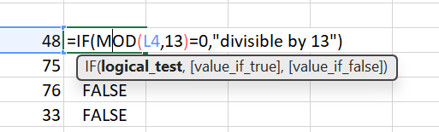

`**VLOOKUP: -**

It is used to give the values from the data of required cell, and input given in vertical order which means for columns

This is the table or data we need to perform VLOOKUP: -

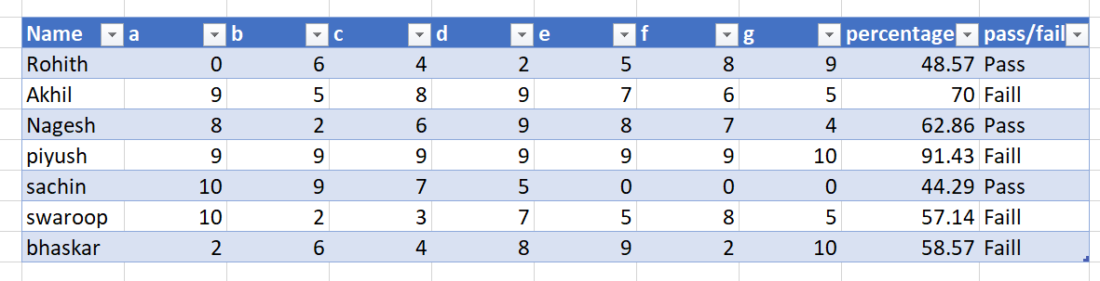



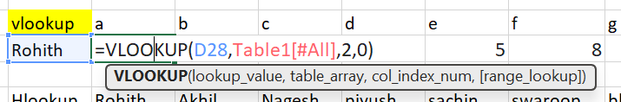

Here from the data a, b, c, d, e, f, g are subjects and Rohith, Akhil… are students

So, we need if we Enter the name of the student, we need the values or the marks from the subject we give. If we change the name of the student the values or the marks are also changes with respect to subject.

Here  D28,🡪 ***lookup_value*** means cell number which have the name Rohith 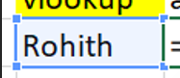

Here Table1[#ALL],  , 🡪 ***table_array*** means total selected table or instead we can select the values without making it as a Table. 🡪 select the total table from the cell column **Name** to cell **Fail** of bhasker row,

Here 2, 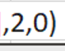 🡪 ***col_index_num*** means mentioning the column Index here Index start from 1 but not from 0

So, subject (a) is a column in table and we are calling it through vlookup, so we give the index of the column.

Index 1=Name, 2=a, 3=b, … 9=Pass/Fail🡪 for columns

Here 0,  means the absolute value as False so we give 0

1= True

0 = False

But giving 0, here we are wanting that we need exact values but not absolute values

**Absolute values: -** it means when we are entering any name and if we made a mistake in spelling or we entered any extra characters in the spelling it will match and gives the values which means it automatically finds the name and gives the marks of him.

**Exact value: -** it gives the exact value if the Name was correct with out any mistakes else it remains same value which we got for previously used Name.

**HLOOKUP: -**

It is similar to Vlookup but its inputs are in horizontally means rows

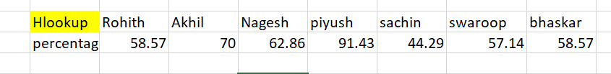

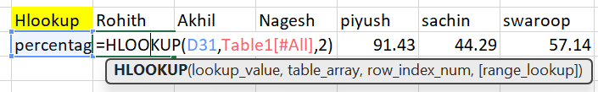

Here  D32🡪 lookup_value, refers the percentage cell in the 2nd image

Here 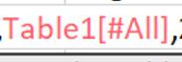 Table[#All] 🡪 table_array, refers entire table selection

Here  2 🡪 index_num, refers the Index of the row Index start from 1

Here I did not mention any number for absolute or exact values so, it automatically takes the exact values.

**Conditional Formatting: -**

Data we are using for conditional formatting

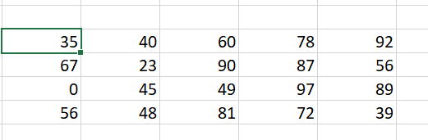

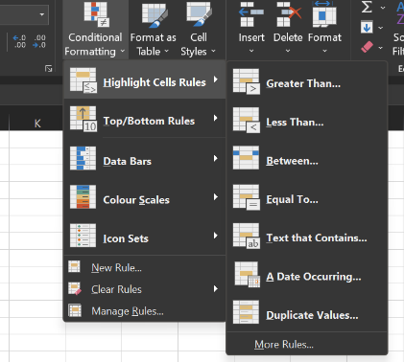

1st select all the values of the data then go to the top In HOME Tab you can see conditional Formatting, click on the dropdown button then you can see this window popup

Give your requirements for formatting the data

After Formatting the data by given requirements

Below 36 red, between 36-79 green, between 80-91 blue, top 10% purple.

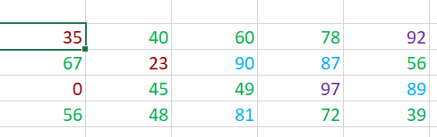

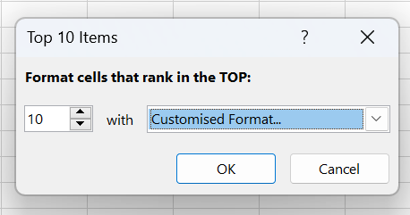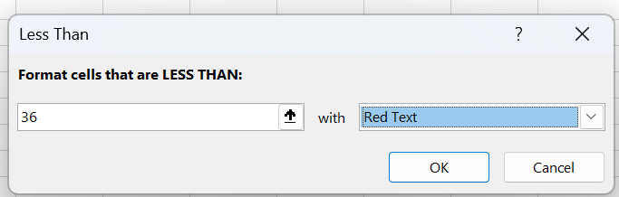

Here by giving the desire requirements we can get the formats accordingly.

**DASHBOARD: -**

**Pivot Table: -**

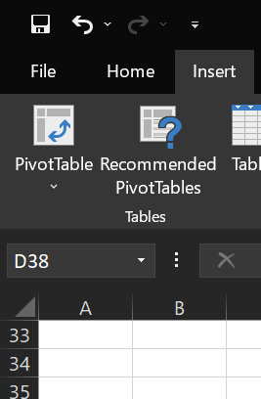

It is a powerful tool to calculate, summarize, and analyse the data that lets you see comparisons, patterns, and trends in your data.

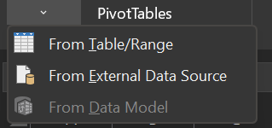1st select the data to make pivot table then go to the “Insert Tab” and you can see top Left corner about pivot table. Click on dropdown button and choose 1st option “From Table/Range”

and choose new worksheet.

Then click ok.

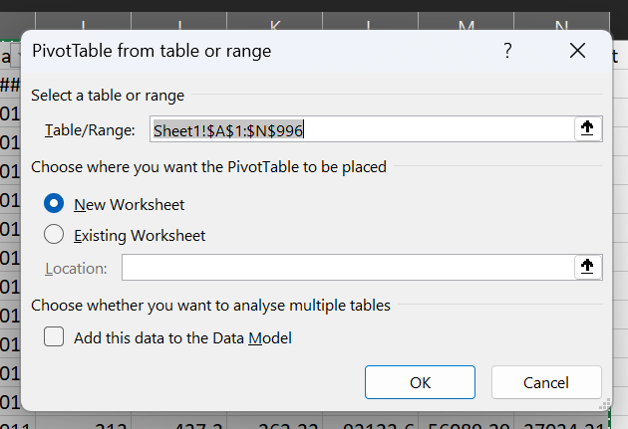

Pivot Table window

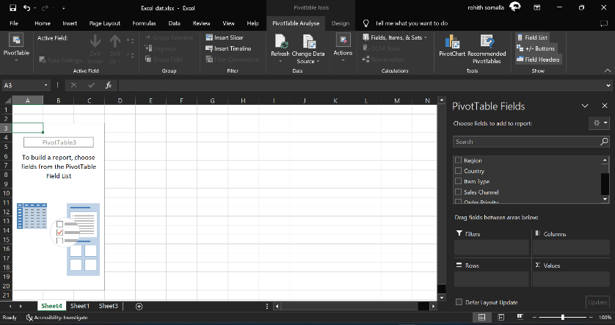

So here at the right side you can see the fields by which you can add the columns and do filtration for visualisation purpose according to our requirements. Then select some columns and go to Insert tab select the charts according to your requirements in visualisation or to make a dashboard.

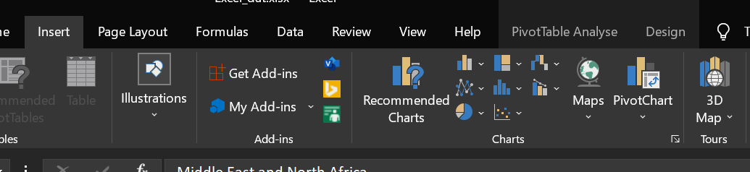

By taking multiple charts and arranging according to our requires gives better Dashboard for presentation or visualisation.

Like after selecting few columns from the field which is right side of the screen

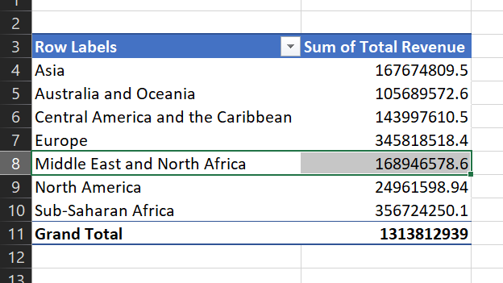

Go to Insert tab and choose one chart according to your requirement

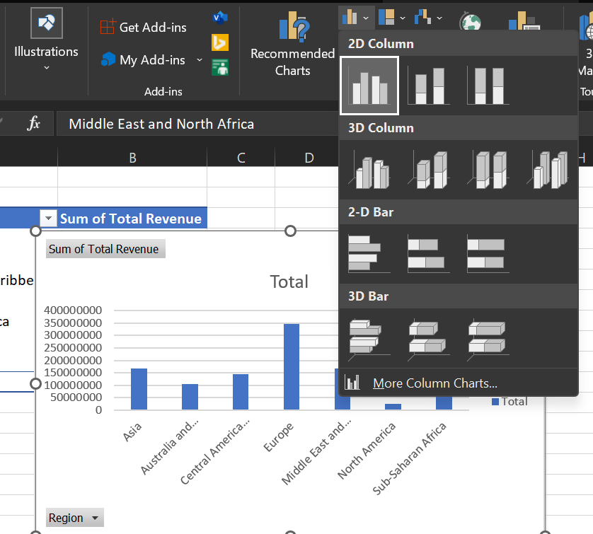

From below dropdown button you can select the columns of x-axis to show or hide.

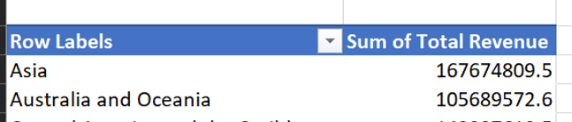

Here click on the dropdown button for the column to filter, sort, take top 10 values etc…

**Dashboard: -**

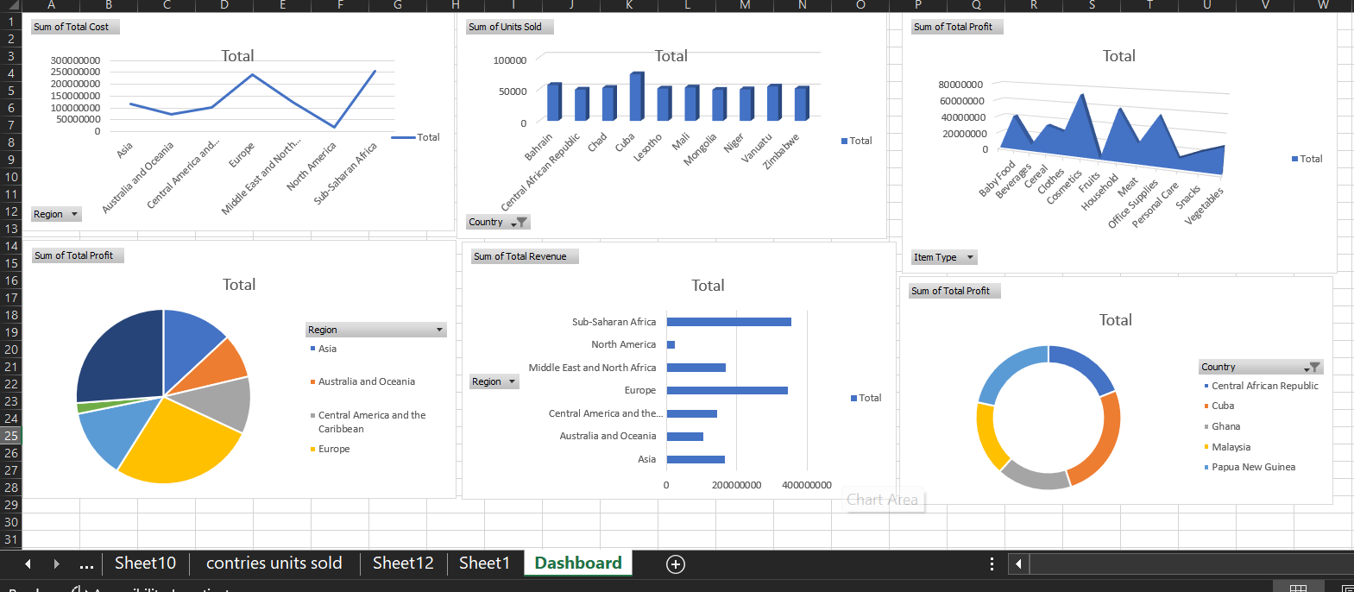

Here you can click on any bar or part or any value you will get to see the all charts with respective your selection.

Auto fit column names according to its length in each cell in Excel

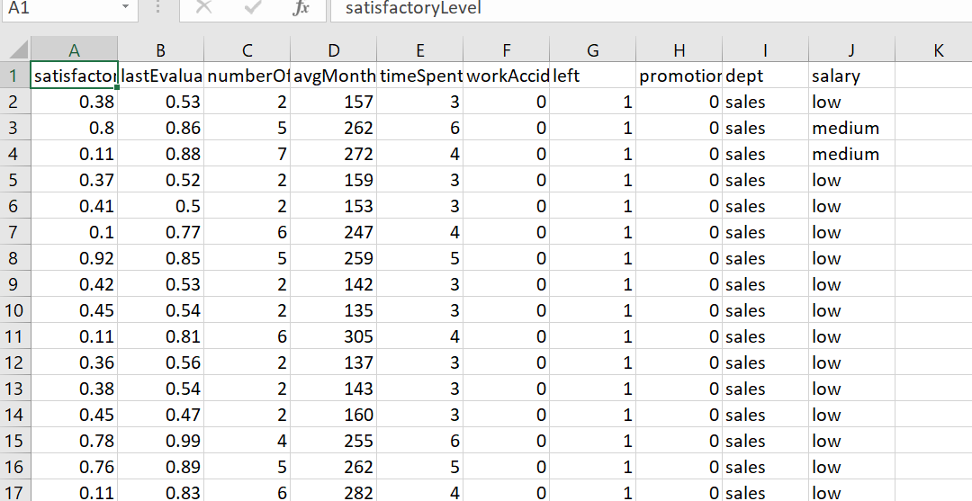

Go to bottom Left 🡪 right click on sheet name

****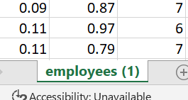

Right click on sheet name here sheet name is employees (1)

****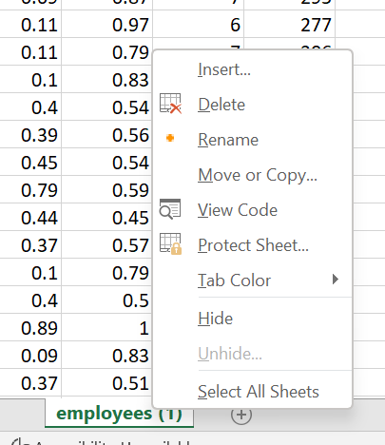

Click on View Code 🡪 then it will automatically redirect to VBA

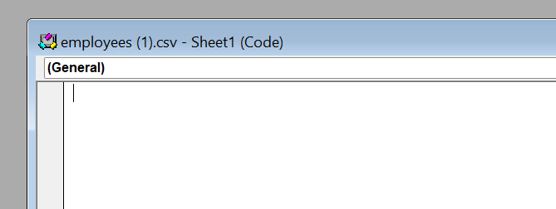

Click on general which is on the top left side of the pop-up window in VBA

Choose Worksheet option right below General

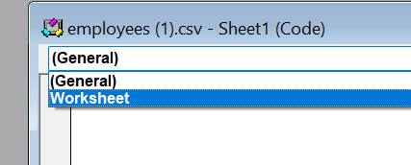

Now Enter the Code between the lines

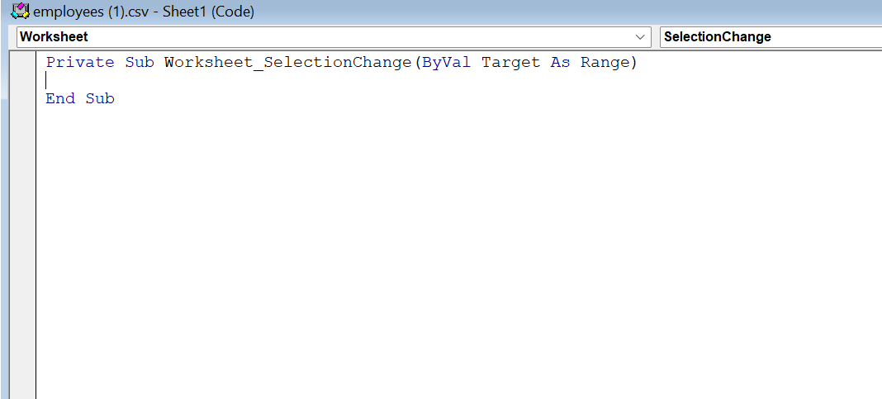

Cells.EntireColumn.AutoFit

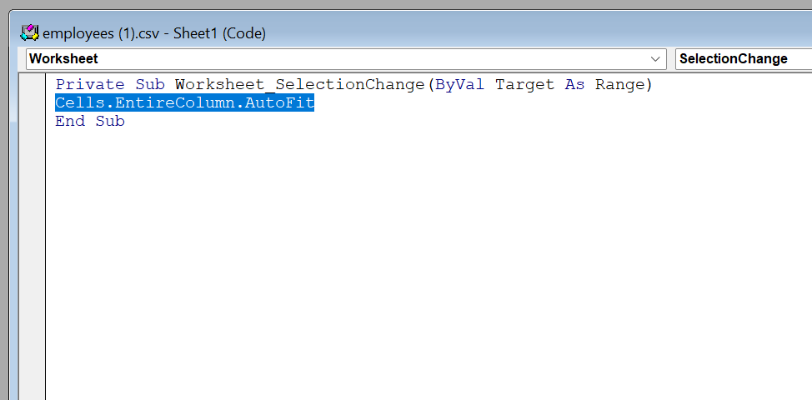

Then close VBA window then go to the excel which cells need to modify

Click on any column name it will automatically adject the size of the cell according to the length of the column name.

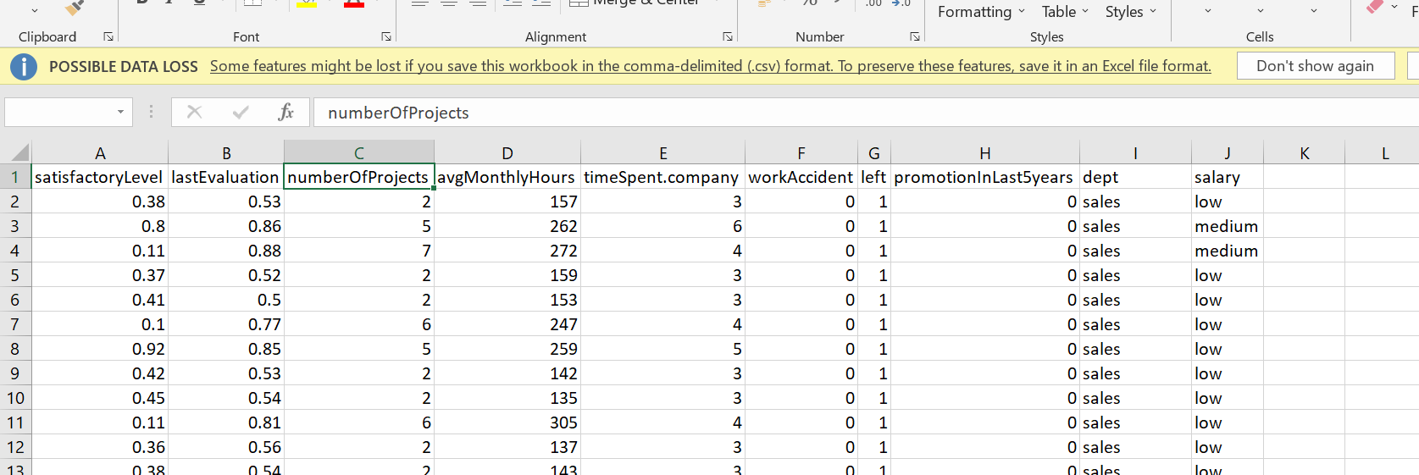

**Formatting Rows and Columns if there are irregular size and shape:**

Select the Entire Dataset then

ALT + H + O + I 🡪 columns

ALT + H + O + A 🡪 rows

For more Data Cleaning Techniques in short: [YouTube **Techie Saumya**](https://youtu.be/3Ylkxvg0hqw)

For Interview Preparation top interview question on Excel : YouTube :

**Chandoo or Chandoo sai**